# Ceph 集群监控

Ceph 集群监控 1

一、 promethues配置 1

1. 配置ceph module 1

2. Prometheus配置及运行 1

二、 Grafana配置 3

1. 安装 3

2. 安装两个插件，加饼状图及曲线 3

3. 安装dashboard 4

4. 配置告警 6

## promethues配置

### 配置ceph module

开启module

ceph mgr module enable prometheus

查看service

[root@node1 prometheus-2.3.2.linux-amd64]# ceph mgr services

{

"dashboard": "https://node1:8443/",

"prometheus": "http://node1:9283/"

}

### Prometheus配置及运行

下载地址：

<https://prometheus.io/download/>

<https://github.com/prometheus/node_exporter/releases/download/v0.17.0/node_exporter-0.17.0.linux-amd64.tar.gz>

<https://github.com/prometheus/prometheus/releases/download/v2.9.2/prometheus-2.9.2.linux-amd64.tar.gz>

将源码包拷至服务器后，修改 prometheus.yml配置文件，将ceph-mgr的监控加入，开启prometheus告警

...

rule_files:

- "ceph_default_alerts.yml"

...

scrape_configs:

- job_name: 'prometheus'

static_configs:

- targets: ['10.127.7.80:9090']

- job_name: 'ceph'

static_configs:

- targets: ['10.127.7.80:9283']

- job_name: 'node-exporter'

static_configs:

- targets: ['10.127.7.80:9100']

...

然后直接运行 ./node_exporter及 ./prometheus两个二进制文件即可

检查端口 9090端口和9100两个端口，保证开启

tcp6 0 0 :::9090 :::* LISTEN 34022/./prometheus

tcp6 0 0 :::9100 :::* LISTEN 38503/node_exporter

直接访问url可以看到Prometheus的数据

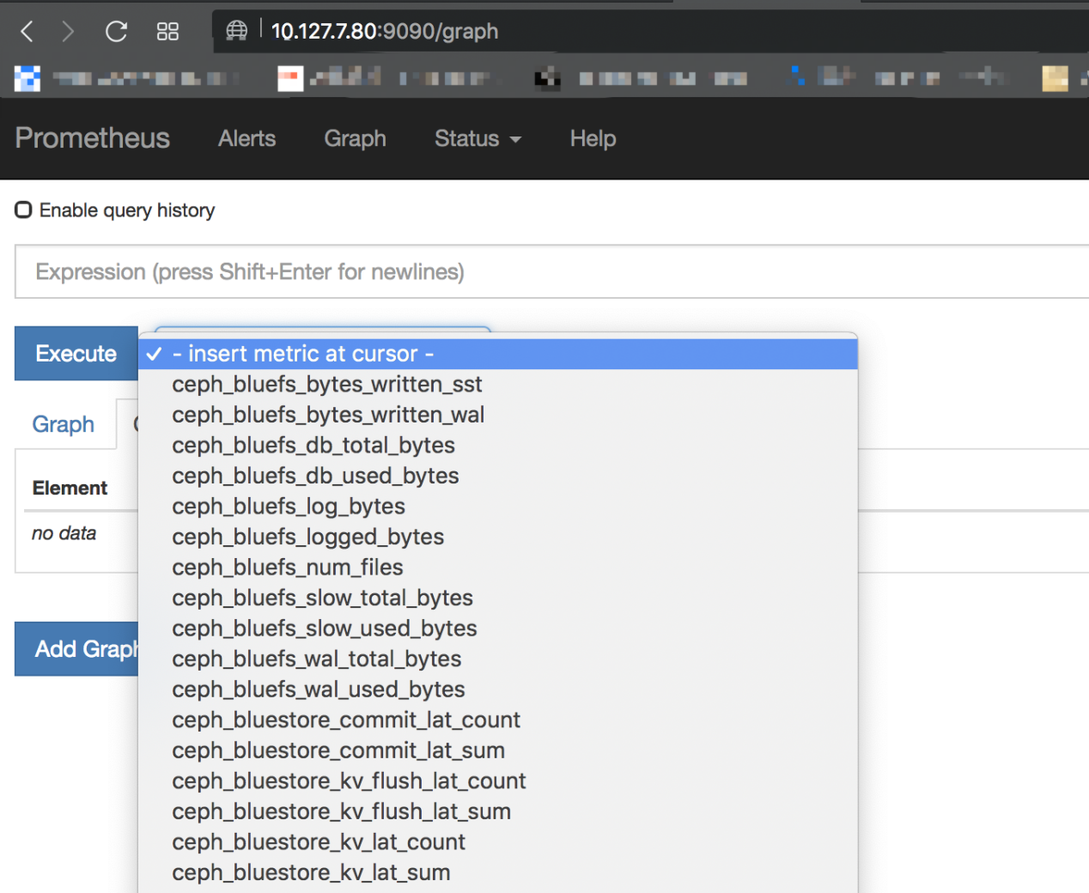

，

在启动时候加上以下参数可以设置存储时长，前提是在磁盘空间允许的情况下：--storage.tsdb.retention

## Grafana配置

### 安装

rpm -ivh grafana-6.1.6-1.x86_64.rpm

systemctl start grafana-server

systemctl enable grafana-server

### 安装两个插件，加饼状图及曲线

grafana-cli plugins install grafana-piechart-panel

grafana-cli plugins install vonage-status-panel

安装完插件重启，url访问3000端口

### 安装dashboard

从官方仓库下载json文件 <https://github.com/ceph/ceph/tree/master/monitoring/grafana/dashboards>

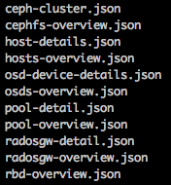

从社区下载

<https://grafana.com/dashboards/8919>

将这些json文件加载到dashboard

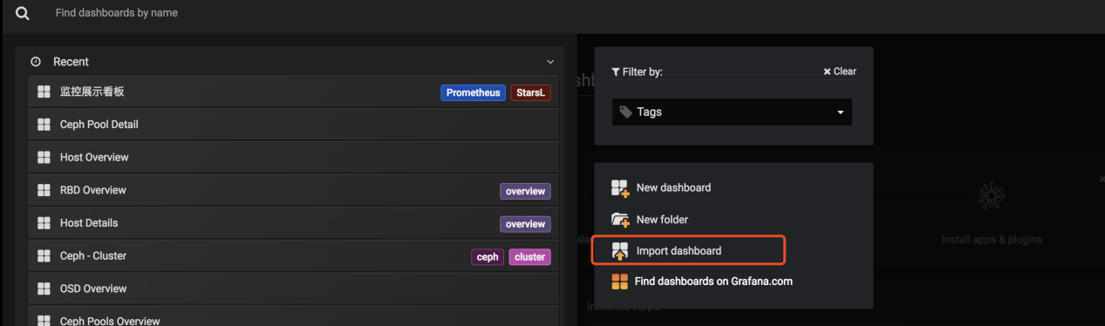

效果如图：

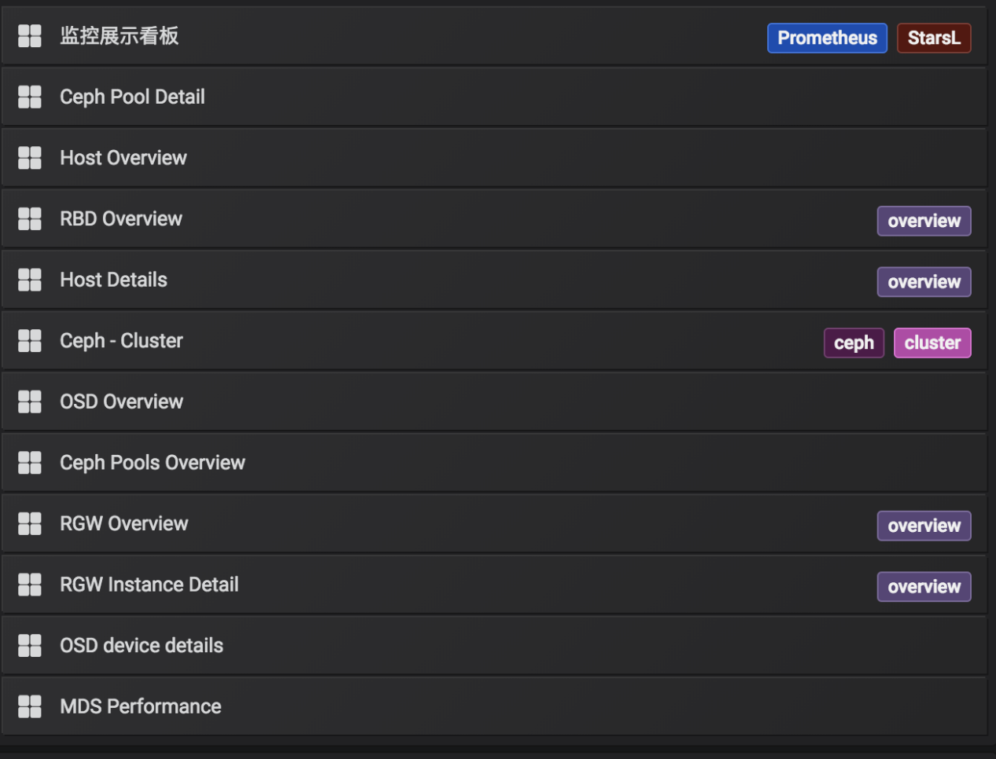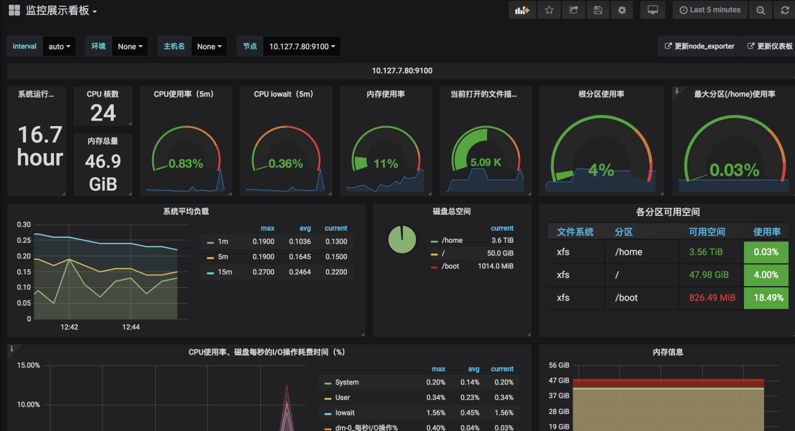

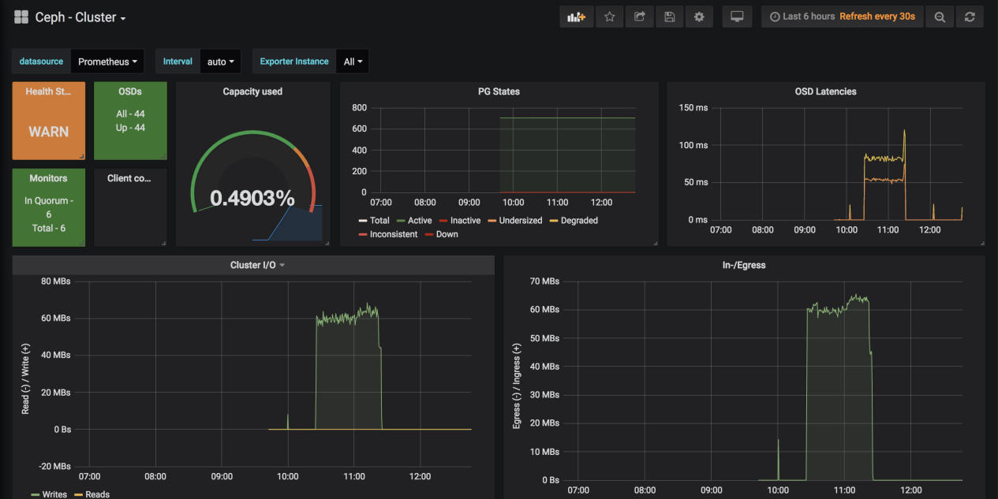

### 配置告警

首先在服务器上修改/etc/grafana/grafana.ini配置

[smtp]

enabled = true

host = smtp.163.com:465

user = xxxx@163.com

# If the password contains # or ; you have to wrap it with trippel quotes. Ex """#password;"""

password = xxx

;cert_file =

;key_file =

skip_verify = true

from_address = 18611305335@163.com

from_name = Grafana

# EHLO identity in SMTP dialog (defaults to instance_name)

;ehlo_identity = dashboard.example.com

[alerting]

# Disable alerting engine & UI features

enabled = true

# Makes it possible to turn off alert rule execution but alerting UI is visible

execute_alerts = true

配置好后重启 systemctl restart grafana-server

然后在页面上配置，写上要接收的邮件地址

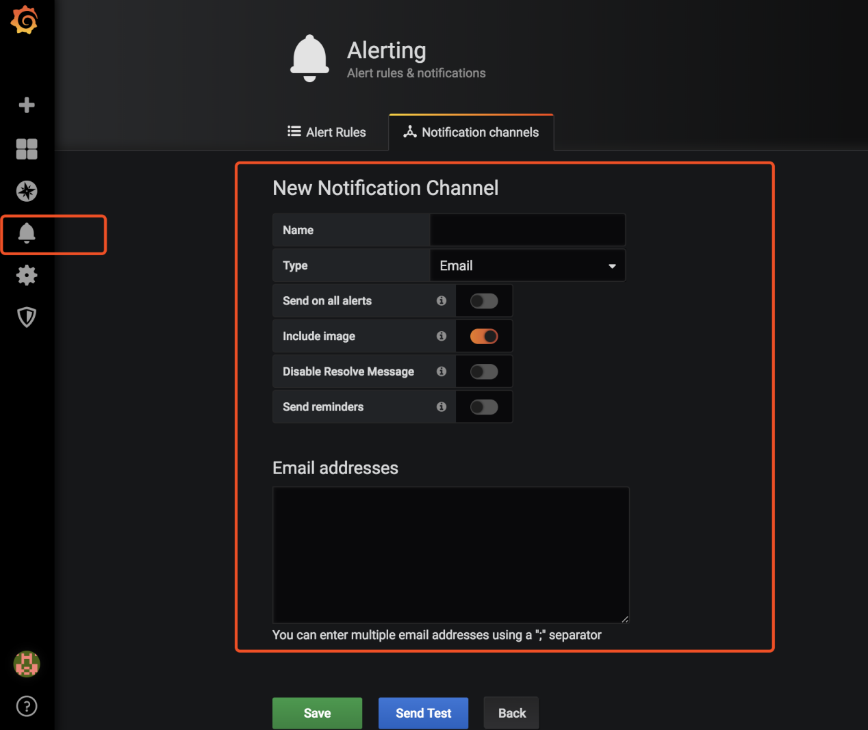

在dashboard上点击要设置的监控项

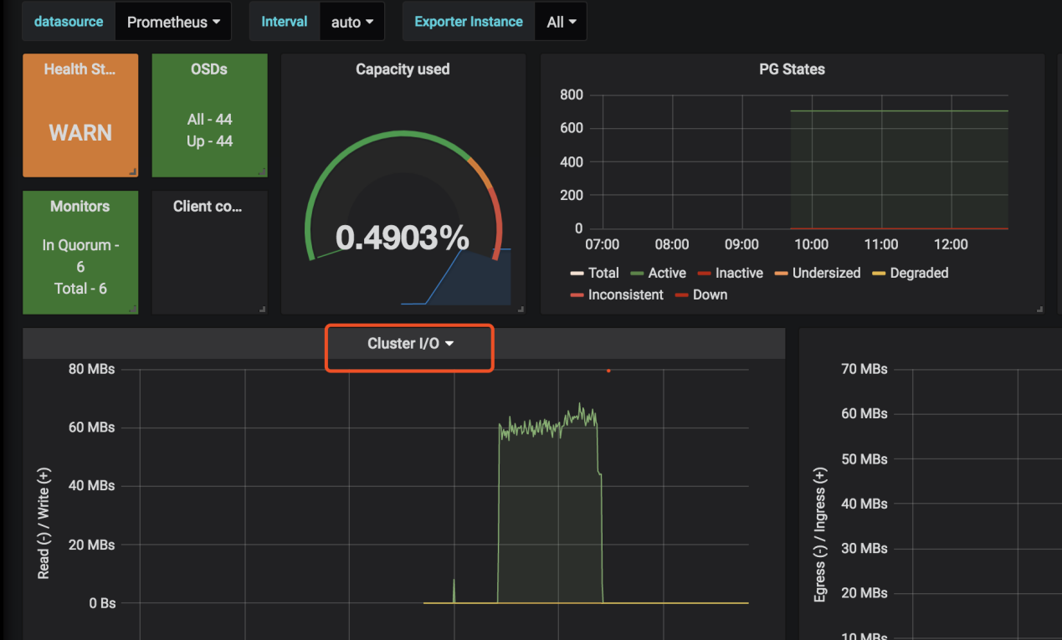

点击告警

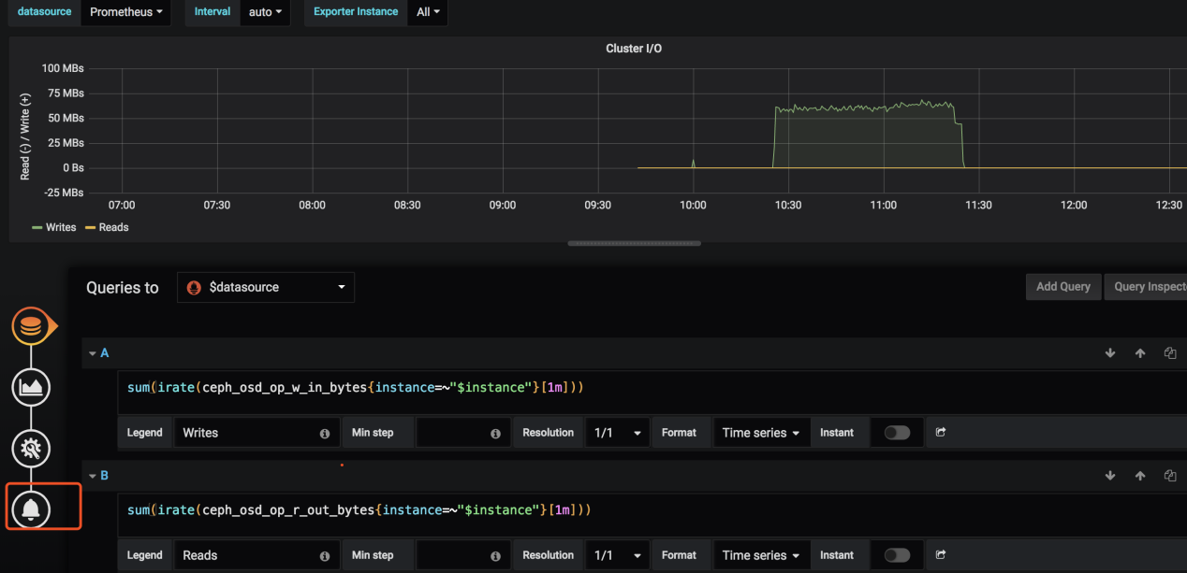

设置告警条件

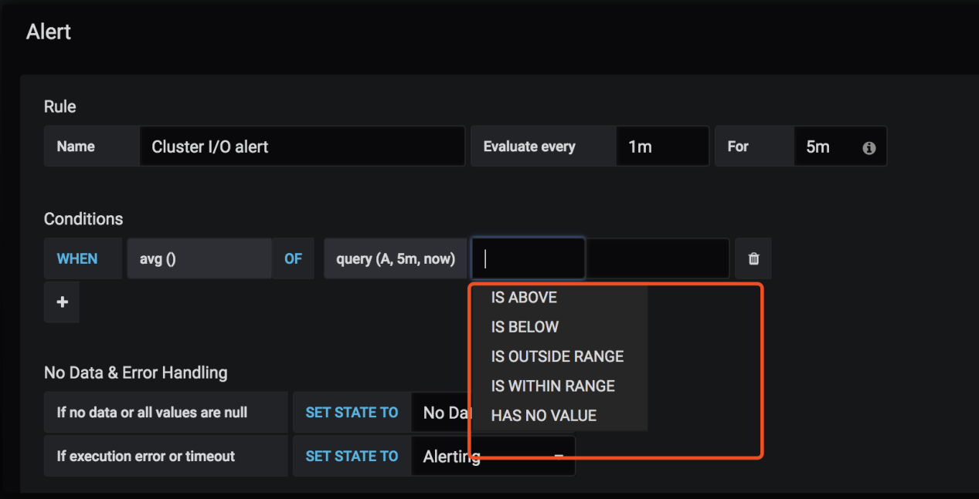

选择发送对象

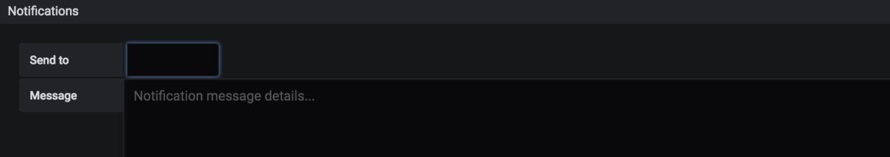

点击测试，如下：

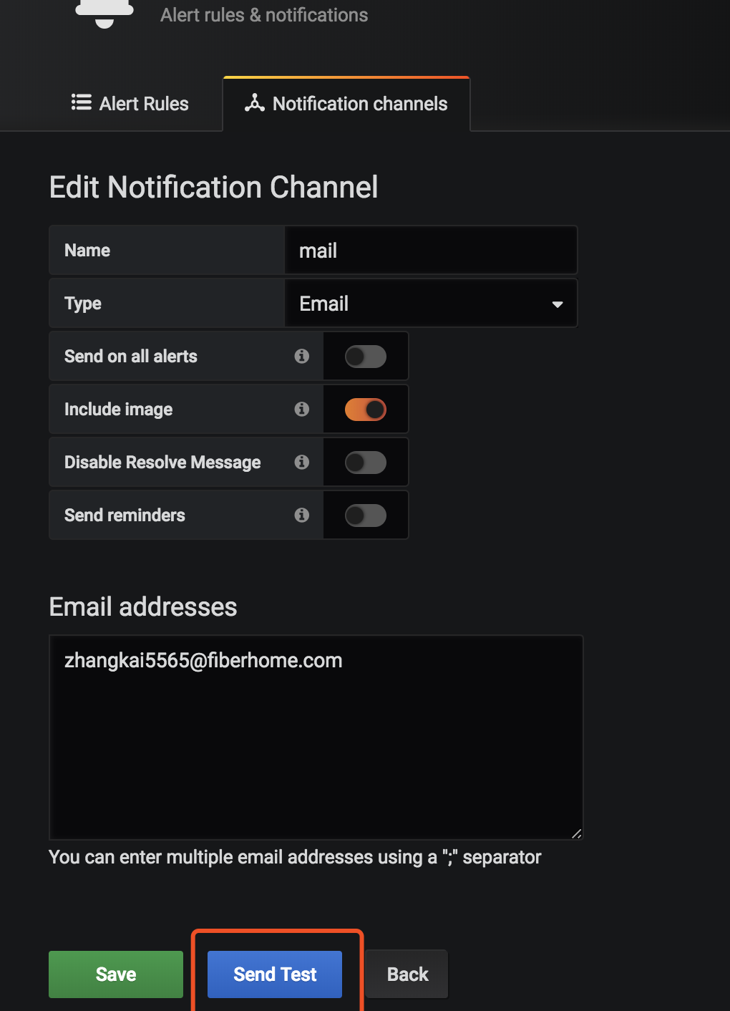

收到的邮件如下：

